Vocabulary Dozen
location | the place or position where someone or something is
medieval | things that happened in or come from the Middle Ages (about 600 to 1000 years ago) are called medieval.
ruins | the remains of something destroyed
invade | to send armed forces into another country in order to take it over
conquer | to defeat an enemy and take control of them by force
rebel | someone who fights against a government or people in authority
defence | the act of protecting or defending from an attack
siege | an attack on a castle, with the goal of capturing it
armour | metal layer worn to protect the body in battle
coat-of-arms | a coloured shield covered with symbols and shapes that represent a knight or noble family
banquet | a feast with lots of food and entertainment. They were held for special guests or celebrations.
monarch | a person who reigns over a kingdom or empire such as a king or queen
joust | a game where two knights tried to knock each other off their horses. These were held at tournaments.
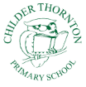
Childer Thornton Primary School Year 2 Autumn Towers and Tails
Facts
Why were castles built?
Castles were built to keep out enemies and to keep the people who lived there and their belongings safe. They were also built to show how rich and powerful the owner was.
Where were castles built?
Castles were built in areas where land needed to be protected from enemies. This meant they were often on borders between countries or on the coast. The best site was chosen for defence so they were usually high up so there would be a good view of any trouble coming. There needed to be a fresh water supply nearby such as a well or a river.
When were castles built?
Castles were built a long time ago (500 to 1000 years ago) when life was very different to today. These times were called the Middle Ages. Things from this time are called medieval.
What was it like to live in a castle?
The way people lived in those times was very different to the way we live today. For example there was no electricity so most jobs were a lot harder. Many children had to go to work and didin’t have the right to learn like children in our country do today.
Who lived and worked in a castle?
monarch or lord nobles
knights ladies in waiting
minstel jester
squires peasants or serfs
People
King Edward 1 | An English king who invaded and conquered Wales.
Robert Mortimer de Chirk | A rich lord who had Chirk Castle built on his land in 1295. King Edward 1 told him to do this to try and stop the Welsh people from rebelling.
The Myddelton Family | A wealthy family who bought Chirk Castle in 1595

Images
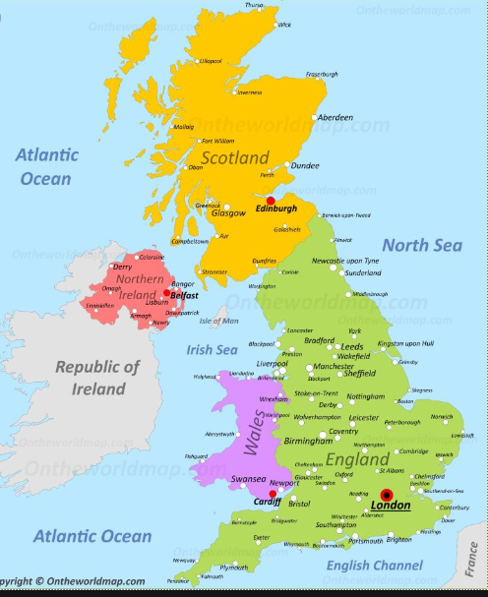
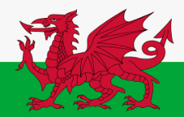
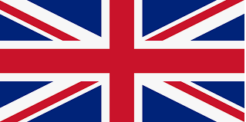

Welsh Flag
Union Flag

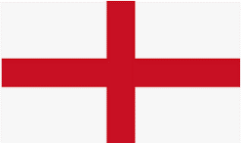
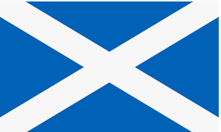

English Flag
Scottish Flag

Were people treated the same in a castle?
The way you lived was very different if you were rich or poor.
Poor
Rich
Clothes | Made from expensive fabrics like linen or silk. They were much more colourful than the poor people’s clothes. Servants helped them to dress. | People made their clothes themselves from cheap fabric like wool. They were usually a dark colour because they didn’t get washed very often. Peasants often only had one tunic.
Food | Held large banquets and feasts. Only wealthy people could afford to eat meat. They had to use lots of salt because there were no fridges. Some of their food was flavoured with spices and honey. | Often couldn’t afford meat so ate food they could grow like pottage – a vegetable stew. They used a piece of hard bread called a trencher instead of a plate. Very poor people were given the leftover bread plates that others didn’t want.
Jobs | Lords owned the land and people had to pay money to them to live and work on it. Knights were rich, important soldiers. They had a squire who helped them. | Most people worked on the land growing crops and raising animals. Servants worked in castles to look after the lords, ladies and nobles. Often servants had to sleep on the floor.

