Vocabulary Dozen
Treaty | Written agreement between countries in which they agree to do a particular thing or help each other.
Tyrant | Someone who treats the people they have authority over in a cruel and unfair way.
Violated | Breaking an agreement, law, or promise.
Seize | Taking control of a place quickly and suddenly, using force.
Invasion | When a foreign army enters a country by force.
Abort | Stopping a process, plan, or activity before it has been completed.
Conflict | A serious disagreement and argument about something important.
Fatality | A death caused by an accident or by violence.
Holocaust | The killing of millions of Jews by the Nazis
Rationing | A system during WW2 to limit the amount of food you were allowed to buy.
Blitz | Attacked by bombs dropped by enemy aircraft.
Evacuate | To send someone to a place of safety, away from a dangerous building, town or area.
Childer Thornton Primary School Year 6 Autumn 1: World at War
Facts
Timeline of Events
1918 | The Treaty of Versailles – ending WW1.
1933 | The Nazi Party came to power in Germany.
1936 | Hitler moved troops into the Rhineland, violating the terms of the Treaty of Versailles.
1938 | German troops invaded Austria.
1939 | German troops invaded Czechoslovakia.
1st Sep 1939 | German troops invaded Poland.
3rd Sep 1939 | Britain declared war on Germany because they had invaded Poland.  The Second World War started.
26th May – 4th June 1940 | Battle of Dunkirk.  Evacuation of British Expeditionary Force and other Allied troops from Dunkirk to England.
July – Oct 1940 | The Battle of Britain. Attacks on British towns, cities and ports from the German air force.
Sep 1940 – May 1941 | The Blitz attacks. German bomber planes attacked Britain at night.
8th May 1945 | Victoria Day in Europe (VE Day).
The Home Front
The Government issued gas masks to everyone in Britain.
German submarines were attacking British ships creating a shortage of supplies. This led to rationing.
Propaganda posters were used to encourage citizens to act safely and support the war effort.
Air raid shelters were built in gardens called Anderson Shelters.
Propaganda Posters
‘Make Do and Mend’
’Loose Lips Sink Ships’
‘Careless Talk Costs Lives’
‘Dig for Victory’
‘Let us go forward together’
Women and Children at War
Children were taught drills on how to get to safety in case of an air raid.
Many children were evacuated from cities to the countryside.
Women worked in factories, as mechanics, the air force and on farms.
Women became more independent, felt valued and were an important part of victory.
People
Neville Chamberlain | Prime Minister of Britain during the outbreak of WW2.
Winston Churchill | Prime Minister of Britain during the majority of WW2.
Franklin D Roosevelt | President of the USA during WW2.
Joseph Stalin | Leader of Russia during WW2.
Benito Mussolini | Leader of Italy during WW2.
Anne Frank | A victim of the Holocaust who kept a diary of her time in hiding.
Images
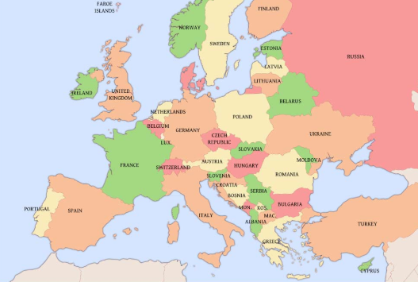

Allies |  | Axis
Great Britain 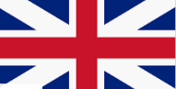 | France | Germany  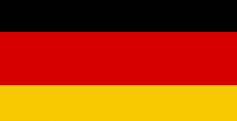 | Japan  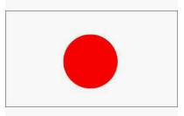
USA  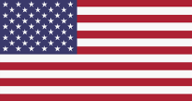 | Russia  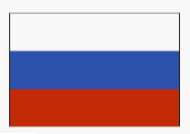 | Italy

Quotes
‘We shall fight on the beaches, we shall fight on the landing grounds, we shall fight in the fields and in the streets, we shall fight in the hills; we shall never surrender’
Winston Churchill,
September 1940

