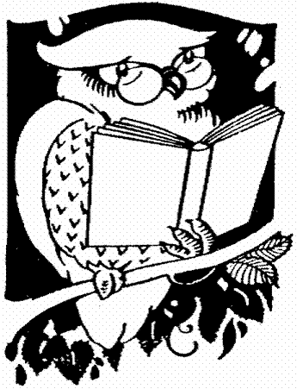
Childer Thornton Primary School
Willow Class - Year 2

together
Grow, enjoy, learn
Welcome back!
I hope you had a wonderful summer holiday. I look forward to working in partnership with you to help your child develop and learn.
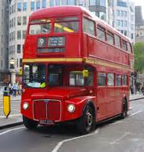
Much of our learning this term will be centred around the topic of ’We’re going on a journey’. There will be a strong focus on history although we will be linking many other areas of learning to this topic. This will include discovering what life was like aboard the Titanic, learning about the first aeroplane flight and looking at how transport has changed people's lives over the years. We will find out about significant people such as Amelia Earhart and the Wright Brothers and consider the impact they made. As part of our values led curriculum, we will also be thinking about different types of journeys such as metaphorical journeys to overcome personal fears or doubts and the journey our food takes to get to us - thinking about food miles and sustainability. As part of our topic, we will enjoy a fantastic learning experience at Liverpool Maritime Museum
In all areas of the curriculum I want to spark the children’s natural curiosity and encourage them to explore and question the things they see, hear or notice.

English

In English we will be using the book ‘Troll Swap’ by Leigh Hodgkinson as inspiration for our story writing. The children will look closely at the features of the text and use it to inspire their own story writing. We will incorporate the use of drama, speaking and listening opportunities and collaborative group work.
Later in the term, we will study ‘The Owl who was Afraid of the Dark’ by Jill Tomlinson along with non-fiction texts about owls. The children will produce some different fiction and non-fiction pieces of writing including poetry, recounts, information texts, letters and instructions.
Throughout all these areas we will be building upon the children’s spoken language skills, developing their vocabulary and encouraging them to articulate and justify their answers and opinions.
This term, we will be teaching the children to master the following skills:

- Plan or say out loud what is going to be written about
- Use punctuation correctly – full stops, capital letters
- Write expanded noun phrases to describe and specify
- Use subordination (because) and coordination (and, but, or)
- Add -ly to turn adjectives into adverbs
- Use commas to separate items in a list
- Write for different purposes
Your child will read with me as part of a guided reading session once a week but I urge you to read as often as possible with them at home as it can have a huge impact on their learning. It is important to check that they are reading fluently, with a good level of comprehension, and are able to answer questions about what they have read. We will also enjoy reading a few pages each day of a class novel. This term it will be ‘Trolls Go Home!’ by Alan MacDonald.

Maths

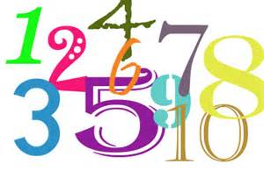
In maths we will continue to extend the children’s knowledge of number and place value. We want to increase the fluency with which they recall addition and subtraction facts and then apply this knowledge across a range of contexts. We will also be working on the children’s ability to solve problems and their mathematical reasoning.

We will move on to recognising the value of coins and working on problems involving money. The children will learn to recognise and use symbols for pounds (£) and pence (p); combine amounts to make a particular value and find different combinations of coins that equal the same amounts of money. They will be taught to solve simple problems in a practical context involving addition and subtraction of money of the same unit, including giving change.

Later on in the term we will begin teaching the children to use and recall multiplication and division facts, including recognising odd and even numbers, with a particular focus on the 2, 5 and 10 times tables. The children will then continue to develop their problem solving in relation to this area.
Science

This term we will be learning about materials and their properties. This will involve lots of exciting hands-on opportunities for the children to work scientifically. They will think about the properties of materials that make them suitable or unsuitable for particular purposes e.g. Which material would make the best ramp for a vehicle? Which material would make the best rain cover to stop a bike from going rusty? The children will devise their own investigations to find the answers to these questions. They will also learn how the shapes of solid objects made from some materials can be changed by squashing, bending, twisting and stretching.
We will think about how to record science data that we gather and begin to use simple graphs and charts to show our findings.

Computing
In computing the children will use Discovery Coding to create an algorithm along with using a range of technology and programs for video and recording purposes. They will also learn the importance of E safety and start to think about ways of keeping themselves safe when using ICT. The children also have many opportunities to extend their computing and technology skills throughout many other curriculum areas such as for science and topic work.

PE
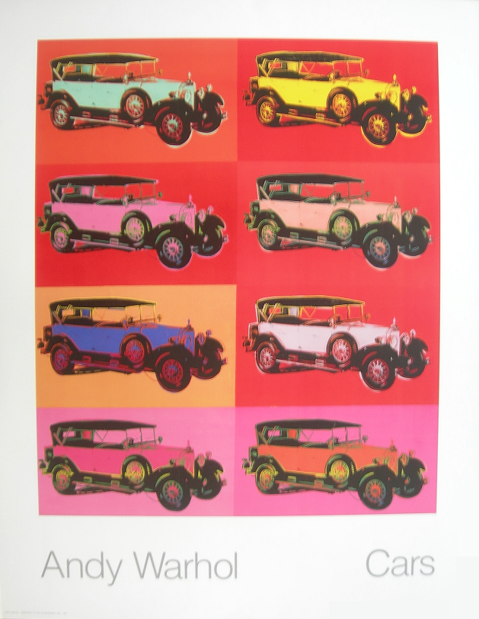
P.E. lessons will be on a Thursday and will be delivered by Mr Grooms. As additional sporting opportunities can often crop up, P.E. kits should be brought into school on a Monday morning and remain in school until the Friday.
Art and DT
Our art and DT will be based on journeys. It will include sketching, pastels, watercolour and collage. We will look at the work of different artists such as Andy Warhol.
The children will also design and make a vehicle with wheels and axles.

Music
The children will be encouraged to listen with concentration and understanding to a range of high-quality live and recorded music and express their thoughts and opinions about it. We will listen to John Adams’ Short Ride in a Fast Machine and discuss what transport the children think inspired the piece and then try to create a soundscape of our own using a selection of tuned and unturned percussion instruments. The children will also be taught to use their voices expressively and creatively by singing songs and speaking chants and rhymes throughout the term and not forgetting the KS1 Christmas performance which we’re excited about already!

RE
During the first term we will look at birth ceremonies from different faiths, special books different faiths use and buildings that are used for worship. We look at how food is used in celebrations and learn about Passover and Christmas. We will think about what makes our world so special, the beauty that is around us and how to preserve that beauty. We will then explore the creation story, make creation poems and learn about St Francis.
Homework
Along with as much reading as possible, homework will be sent out as follows:
- Learning Logs will be sent out on a Friday. Children have two weeks to complete the set task. Please encourage them to be as imaginative and creative as they can be with the presentation of their work. This is a lovely opportunity for them to showcase their personalities and individual flair.
- Spellings will be sent out on a Monday to be returned on the Friday of that week. This will be in the form of a spelling investigation e.g. children will be given a spelling rule or pattern such as –dge and they then find as many words with that pattern as they can (edge, dodge, badge etc.) and try to use the words in a sentence.
- My Maths will be set on a Friday for children to complete within a week.

Useful Websites

https://www.bbc.com/bitesize/levels/z3g4d2p

www.woodlands-junior.kent.sch.uk/maths/

http://www.counton.org/

http://www.nrich.maths.org/public/monthindex.php
http://www.ictgames.com/resources.html
https://www.phonicsplay.co.uk/
http://www.crickweb.co.uk/ks1numeracy.html

Finally, I am very much looking forward to working with your children this year. I believe strongly in the partnership between a child’s home and school life so if you have any questions or wish to discuss any aspect of your child’s development or learning then please don’t hesitate to get in touch.
Thank you,
Mrs McManus

